Step1. Release all of the hand screws.
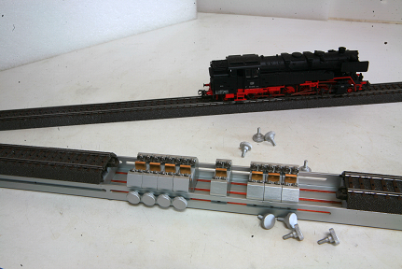

Step2. Then take the bearing set out of alumina stand.
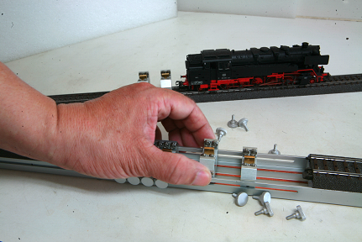

Step3. Put the bearing set on the track and slide it until the track groove coating was broken.
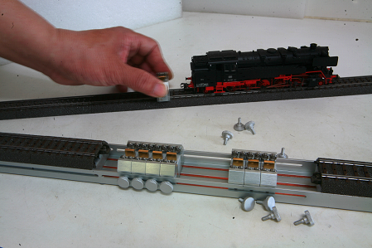
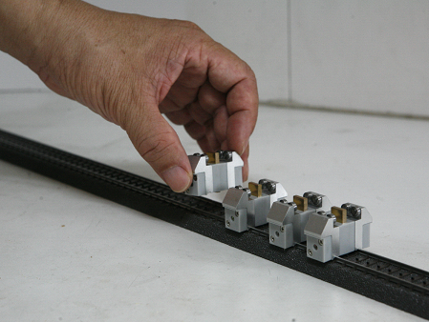

Step4: Make sure the bearing sets are conduct electricity
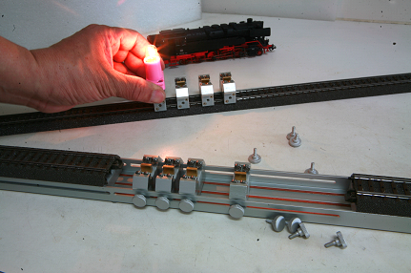

PS: If you the light didn’t work, please check the two furrows on the bottom were conduct
electricity, if isn’t you can use the rasp to make the furrows were conduct electricty.
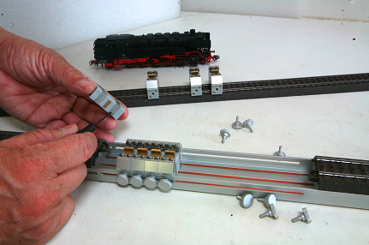

Step5: Put the locomotive on the bearing-sets
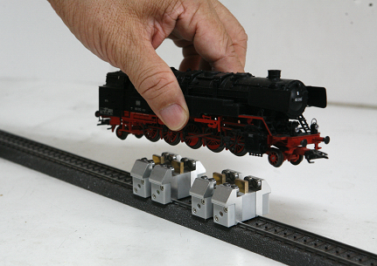

Step6: Turn on the power then drive it.
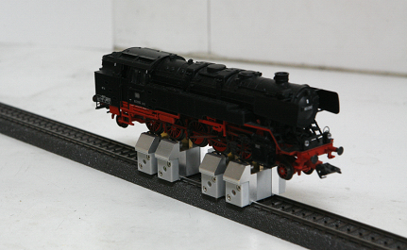

PS: The bearing set available for the AC or DC locomotive on the bearing sets

